Point-of-Sale System
- The optimal solutions for all retail sales stores.
- Calculation of sales amounts through scan reading of item number by barcode scanner.
- Issuing sales invoice for customer with details of items sold.
- Handling returns of partial and whole sales, doing the inventory effect accordingly.
- Issuing reports required for sales processes in each point of sales.
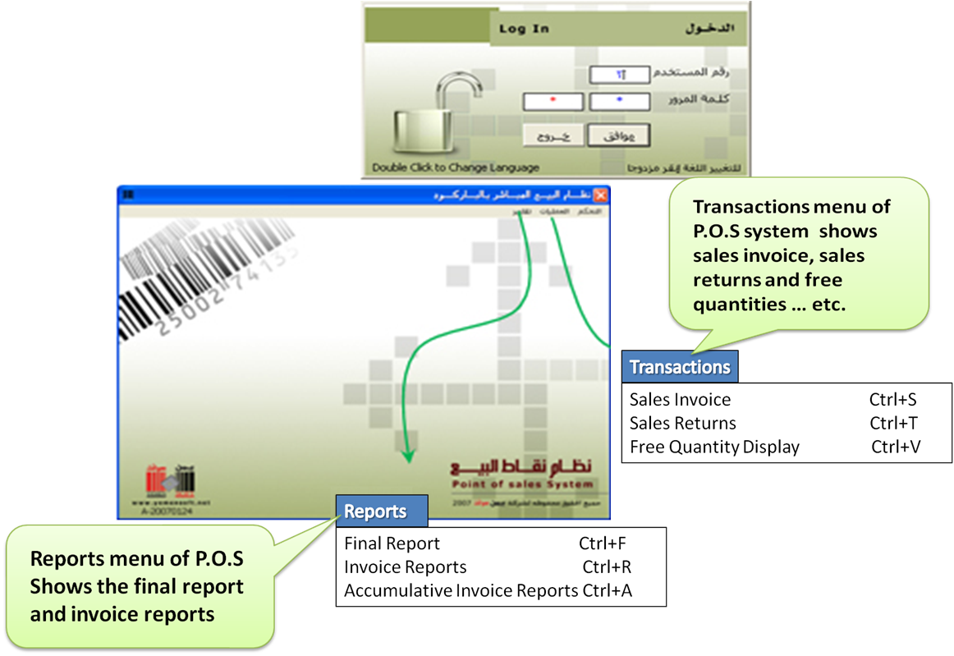

The system benefits
- Getting rid of miscalculations, mistake of pricing and customers crowding queues.
- Speed, accuracy and flexibility, providing service for a big number of customers.
- Issuing sales invoices, sales returns and free quantities, handling them according to setting.
- Defining users’ authorities and privileges on system functions.
- Easiness and speed in sales processing from several points with one invoice, during work time.
- Monitoring of sales transactions in sales centers or of points in one center.
- Dealing with credit cards as one of payment options available, dealing with various currencies.
- Displaying all invoices according to definite conditions from starting using system to time of report display.
- Full integration with Al Motakamel package.

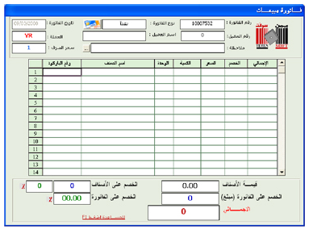
Some Screen of P.O.S System

Sales invoice screen through which direct sales process is done.
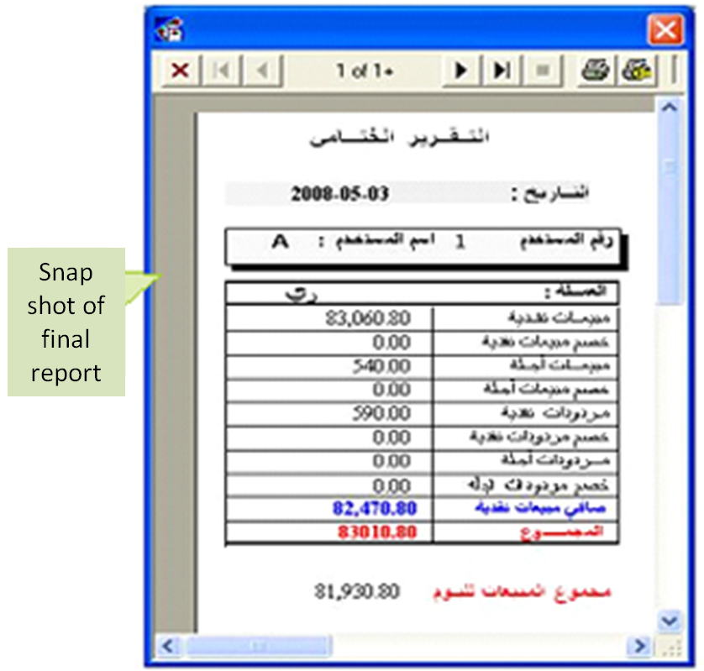

Report of sales invoice, displays non-posted invoice (to accounting system) in point of sales for each user and according to invoice type.
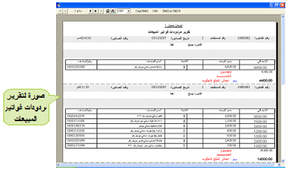

Reports of accumulative invoices – Through these reports all invoices can be displayed with several options

Questions & Answers
- Can user display the invoices that have been posted form a point of sale to the Accounting system?

- Yes, this can be done by inputting them through the screen of traveler data via the screen of sale invoices which are displayed in the reports.

- Can user make free quantities from other items?

- Yes, he can do that by inputting those quantities through the display screen of free quantities.

- Can the system deal with percentage or specified discount?
- Yes, according to the privileges and this function is done for clients, items, and others.

- Is cash and credit sale process done at cashier directly?
- Yes, according to predefined privileges.

- How does the system deal with the items which are not bar coded?
- Barcode printers are used to identify non-bar coded items and then they can be read.

