Specialized Solutions for Various Fields
Solutions for Tourist Organization
Hotel Management System
- The Most Important Function System:
- Performing the processes of reservation and hosting guests, controlling of room changing and leaving according to the privileges that hotel presents to their clients whether they are individuals, groups or companies.
- Documenting the services provided to clients and issuing detailed invoices for cash and credit services.
- Controlling the phone calls of guests and providing detailed data of calling activity with several options.
- Issuing brief and detailed reports of organization documents, their contents, categories and variety of data.
- Recording the revenues of the services provided in the account of guest according to services invoices.
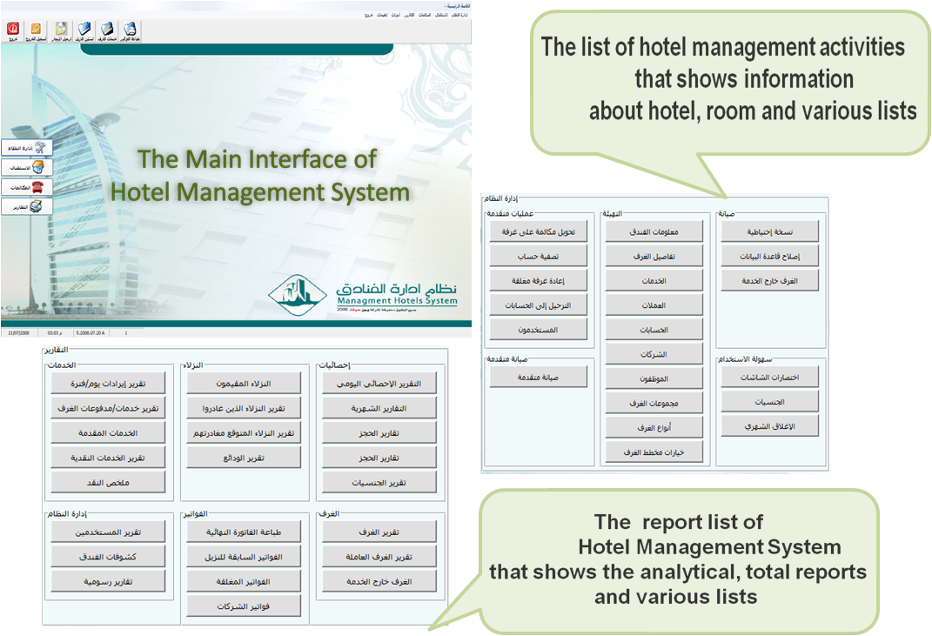
- Viewing various reports of operation activity with multi-option.

1

1

Hotel Management System
- تعامل النظام مع أي تحويلة ترتبط إلى طابعة (Panasonic - Avaya - Alcatel - Nortel..)
- .
- Some Benefits of System
- Knowing rooms position (Vacant - Reserved - Occupied) any time.
- Precision, control, monitoring and carefree for hotel owner and manager in addition to easiness, flexibility and efficiency for performance of hotel manager and employees, besides high-class services for guests.
- Control of hotel clients such as companies and groups according to the privileges granted to them.
- Automatic processing of tax and allowances of individual and companies.
- Swiftness of guest service through controlling of accommodation and the flexibility of the system with all services( room rents – phone calls – restaurant – laundry – payments –returns – discounts … etc.)
- Recording all incoming and outgoing phone calls details and posting the charges to the customer invoice automatically.
- Controlling guest calls and implementing the requirement of maintenance rapidly and effectively.
- Compatibility of the system with any kind of phone switchboard connected to printer (Panasonic - Avaya - Alcatel - Nortel).
- Full integration with YemenSoft applications.

2

Hotel Management System

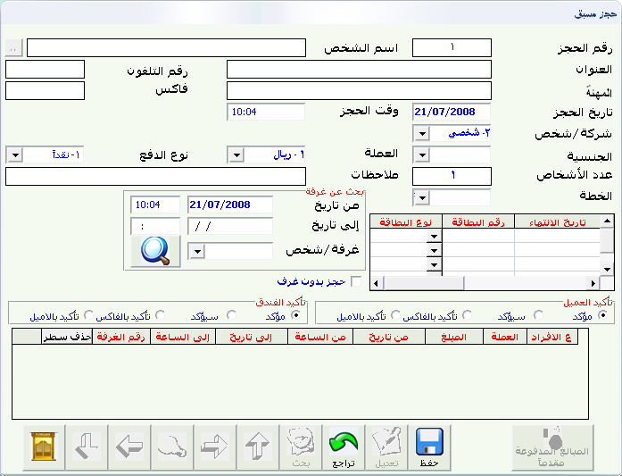
- Snapshots of Electronic Archiving System:

Reservation Screen: Through which preservation of room or a suite or more is done for a defined guest for a certain period so that no other guest can be resided in that room or suite during that period.

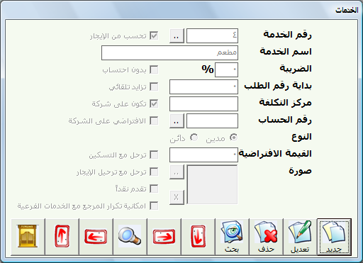
Services Screen: Through this screen coding of all services provided to clients is done, whether the services are debit or credit.

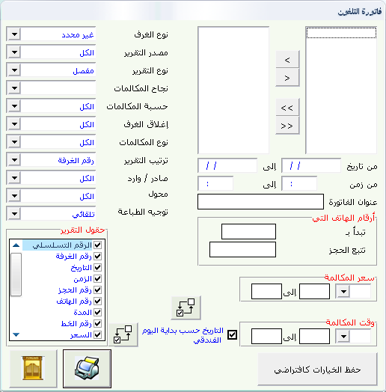

Bill of Phone Calls: Printing of several various phone calls reports (total or analytical) is done through this screen. Reports can be at level of room, reservation or number for any period.

4

Hotel Management System
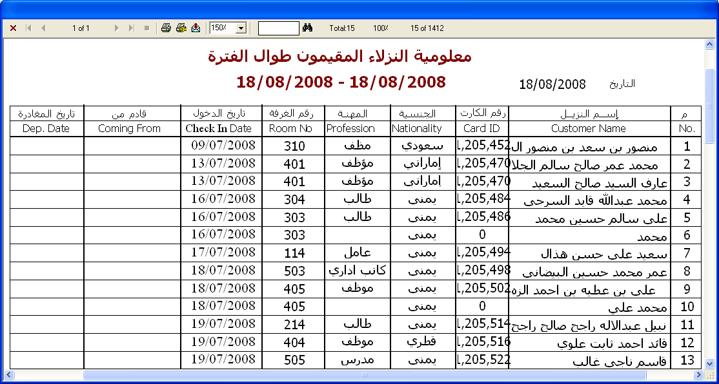
- The Most Important Report :
- Report of Resident Guests (Guests Manifest): This report shows all the data of resident guests at current time or any period.
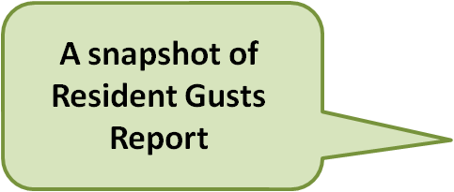

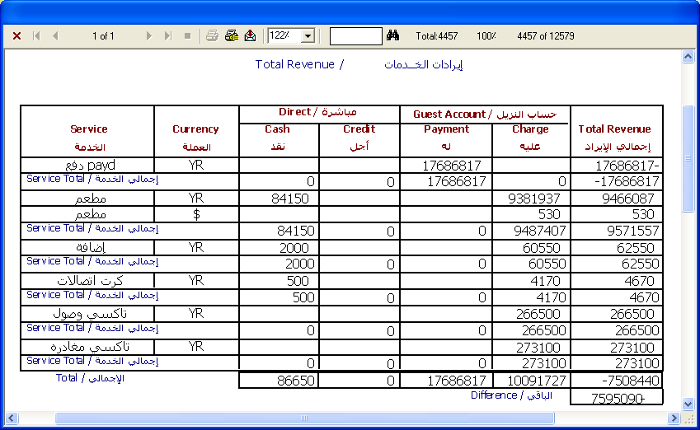
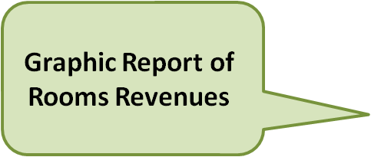
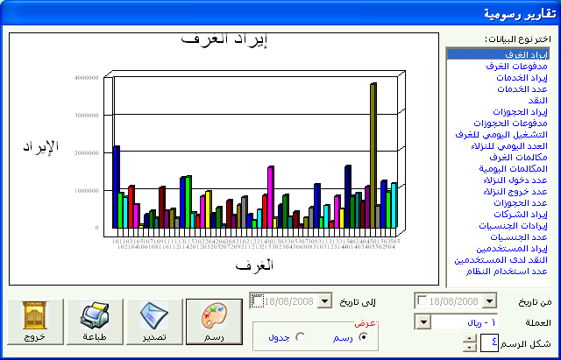
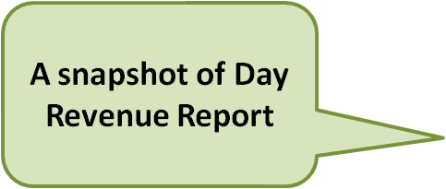
- Graphic Report of Rooms Revenue: This report shows the total revenue of each room during defined period.
The Graphic diagram is available for many reports with different and good formats.
- Report of Revenues: This report shows the revenues of services provided to guests

5

Electronic Archiving System
- Frequently Asked Questions
- How does the system deal with guests who belong to a certain organization?
- Services will be provided to guest are defined whether charges are fully, partially paid or by percentage with defining the name of organization which guest belongs to. This procedure is done during hosting guest.
- How does the system handle the invoice of multi room?
- It is possible to print an invoice (a bill) for a room or for all engaged rooms which are still open or for all engaged rooms either open or closed.
- How does the system post transactions to accounting system?
- System can post a separate service or all services with one currency or all currencies. It is also possible posting all rooms whether open or closed and the services whether cash or credit or all of them. System also can post quantities from restaurant as a sales invoice to the accounting system or as inventory outgoing order.
- How much effective is the System of Calls Picking up?
- The Calls Picking up System depends on the type of the phone switchboard used, System deals with different types of switchboard, it records all phone calls from the rooms, the reception or from any switchboard to calculate the charge of every call according to the prices already input.
- Does the system provide rooms’ diagram that illustrates room position (Vacant - Occupied – Reserved) at current time?
- There are two types of diagrams with two different forms so that rooms are drawn with defined colors by user to distinguish between the vacant rooms from the reserved rooms and the ones which are under maintenance. Most of the essential data of rooms can be shown at real time such as (Guest Name – Company – Number of services – Residence Date – Expected Date of Leaving … etc.) Any of these data can be hidden according to the user wish. Besides, control the dimensions, the font of the diagram and the number of rooms in each line of the diagram in addition to several of functions without the need of going to another screen such as (Guest Hosting - Rent Posting - Adding Services - Bill Printing – Guest Out-going – Showing the Room Photo – Terminating Room Maintenance…etc.)

5

